# **Practical – 8**

**Aim:** **Data/Object classification using CNN**

* Code:

import pandas as pd

import numpy as np

from sklearn.model_selection import train_test_split

from sklearn.preprocessing import StandardScaler

from tensorflow.keras.models import Sequential

from tensorflow.keras.layers import Conv1D, MaxPooling1D, Flatten, Dense, Dropout

from tensorflow.keras.utils import to_categorical

data_set = pd.read_csv('/content/drive/MyDrive/temp/practical_4_2.csv')

X = data_set[['Match_Duration', 'Loot_Collected', 'Enemies_Defeated']].values

y = data_set['Player_Score'].values

y_class = pd.qcut(y, q=3, labels=[0, 1, 2])

y_class = y_class.astype(int)

X_train, X_test, y_train, y_test = train_test_split(X, y_class, test_size=0.2, random_state=42)

scaler = StandardScaler()

X_train = scaler.fit_transform(X_train)

X_test = scaler.transform(X_test)

X_train = X_train.reshape((X_train.shape[0], X_train.shape[1], 1))

X_test = X_test.reshape((X_test.shape[0], X_test.shape[1], 1))

y_train_cat = to_categorical(y_train, num_classes=3)

y_test_cat = to_categorical(y_test, num_classes=3)

model = Sequential()

model.add(Conv1D(32, kernel_size=2, activation='relu', input_shape=(3, 1)))

model.add(MaxPooling1D(pool_size=1))

model.add(Flatten())

model.add(Dense(64, activation='relu'))

model.add(Dropout(0.2))

model.add(Dense(3, activation='softmax'))

model.compile(optimizer='adam', loss='categorical_crossentropy', metrics=['accuracy'])

model.fit(X_train, y_train_cat, epochs=50, batch_size=8, validation_data=(X_test, y_test_cat))

loss, accuracy = model.evaluate(X_test, y_test_cat)

print(f"Test Accuracy: {accuracy*100:.2f}%")

* 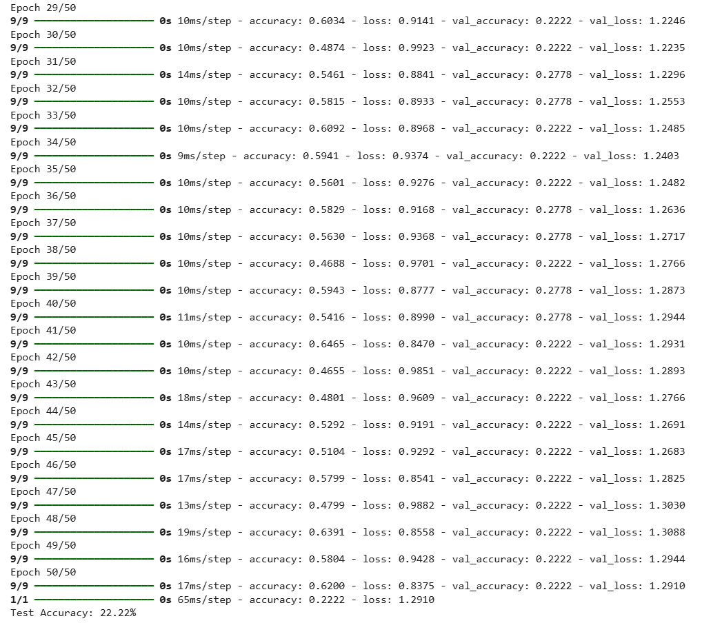Output

Faculty Signature: _______________ Date: _____________________